1. When creating a project build we want that build to be portable so that our project can be built upon many different environments often within our organizations.
2. **Different Environments**:
   1. Dev
   2. Test
   3. Product
3. We need to customize the behaviors and configurations of our build in order to be able to deploy to those different environments.
4. There is a custom set of properties for each environment that we’re working within.
5. **Solution**: Maven profiles allow us to build our project for those different environments.
   1. It gives us a mechanism to customize our builds depending upon the environment we’re targeting.
6. So within our pom file, we are able to specify a profile which will define an alternative set of configurations for a particular environment to get start.
7. 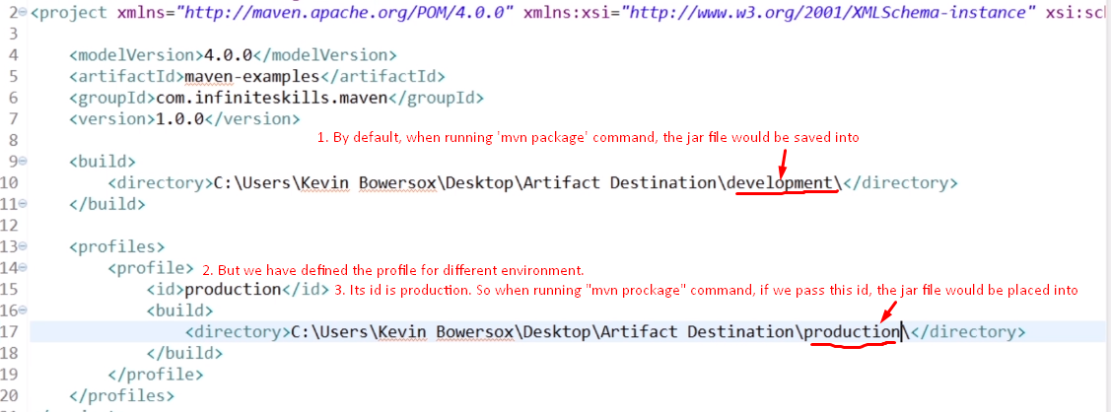
8. 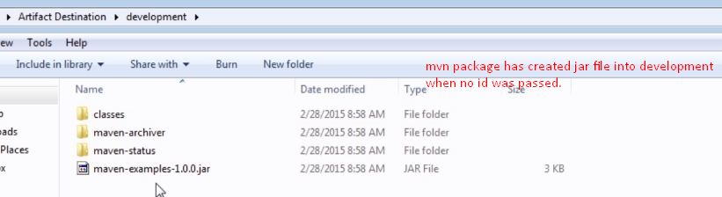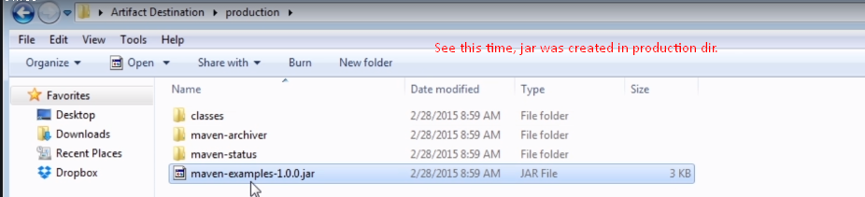
9. Sometimes, we don’t want to apply the profile by providing the profile id during command execution as flag sometimes even it’s not possible to pass flag.
10. **Alternative**: Activation. It means to look at something else rather than –P flag to apply a particular profile.
    1. **what is that something else**? Maybe environment variable. Based on that environment variable, a particular profile would be applied.
    2. 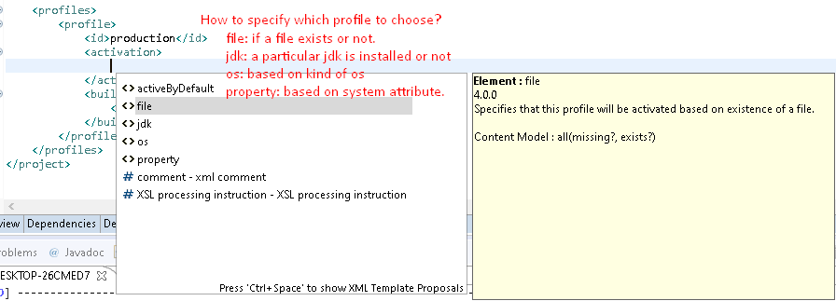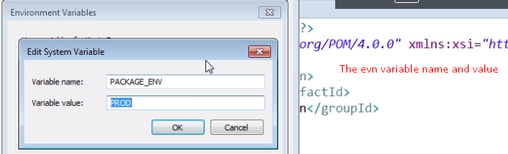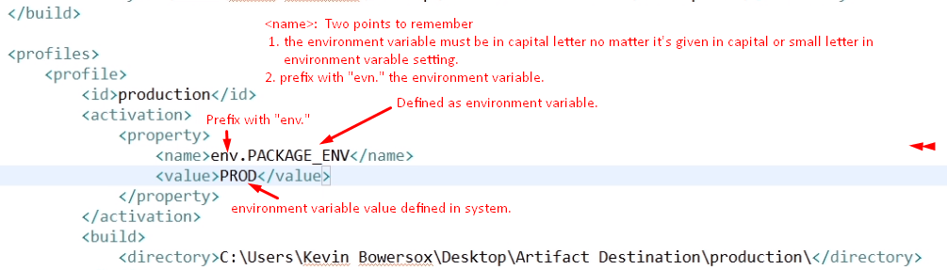
    3. 